

**FUNDAMENTAL OF PROGRAMMING**

**INSTRUCTOR:MUHAMMAD AFFAN**

**HOME TASK**

**Submitted by : ABDUL MANAN**

**CMS ID: 462449**

**TASK 1 : write a code for calculating factorial of 6**

#include <iostream>

using namespace std;

// finding the factorial of 6

int main (){

int num; // defining a space where user can write the number 6

cout<<"write number 6 here to calculate its factorial"<<endl; // printing the instructions onto the screen

cin>>num; // the number 6 is typed here

cout<<(num-5)*(num-4)*(num-3)*(num-2)*(num-1)*(num-0)<<endl; // formula for the factorial of 6

}

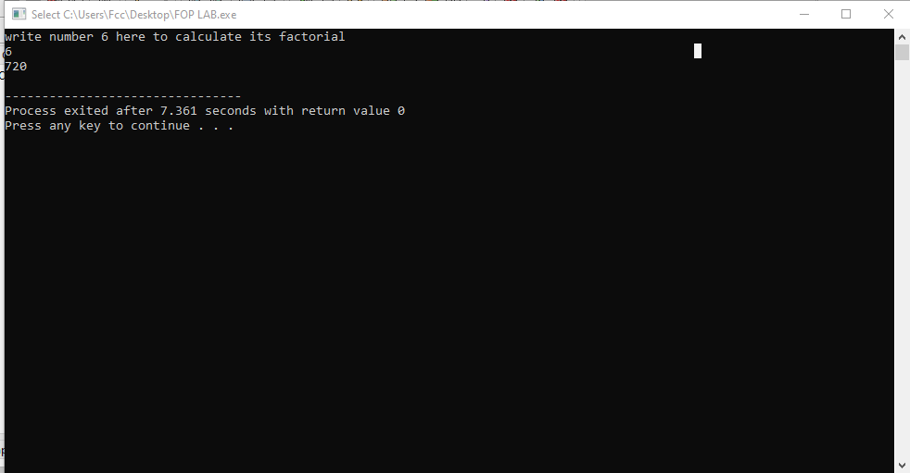

**TASK2: write a code for finding distance between two points**

#include <iostream>

using namespace std;

//taking two set of coordinates from user and finding the distance between the points

int main (){

float D,x1,y1,x2,y2;

cout<<"Write x1 and y1 coordinate here"<<endl; // this will print the instruction on the screen asking the user to fill in the first set of coordinates

cin>>x1>>y1; // user will input the set of coordinate in the given memory here

cout<<"Write x2 and y2 coordinate here"<<endl; // this will print the instruction on the screen asking the user to fill in the second set of coordinates

cin>>x2>>y2; // user will input the set of coordinates in the given memory here

cout<<"The distance between the two sets of Coordinate is"<<endl;

D=(((x2-x1)*(x2-x1)) + ((y2-y1)*(y2-y1)) ); // calculating the distance with given formula

cout<< D <<endl;

return 0;

}

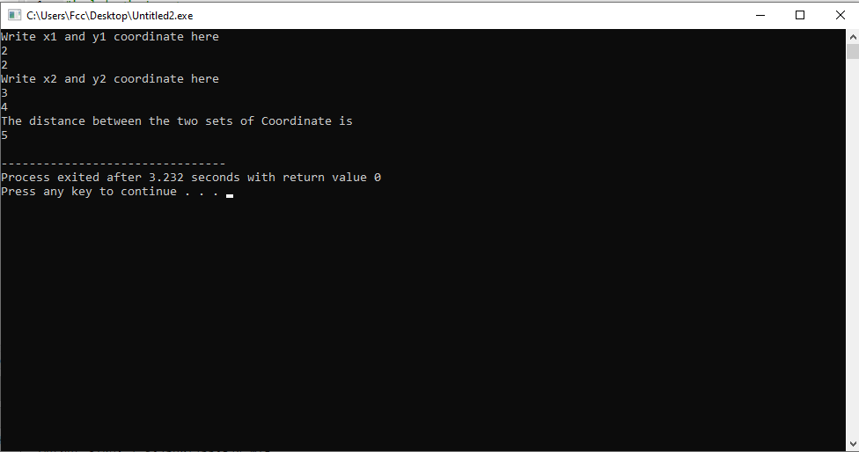

**TASK3: write code for converting length from centimeter to meter and kilometer**

#include <iostream>

using namespace std;

//Converting lenght from user in centimeter and converting it into meter and kilometer

int main (){

float lenght; //creating a memory space for user to input data in

cout<<"write the lenght in Centimeters"<<endl; //printing instruction on the screen to let user know which data is to be added

cin>>lenght; // user will add lenght in centimer

cout<<"The lenght in meters"<<endl;

cout<< lenght/100<<endl; // by dividing the lenght by 100 we will get lenght in meter

cout<<"The lenght in kilometer"<<endl;

cout<< lenght/100000<<endl; // by dividing the lenght by 100000 we will get lenght in kilometer

return 0;

}

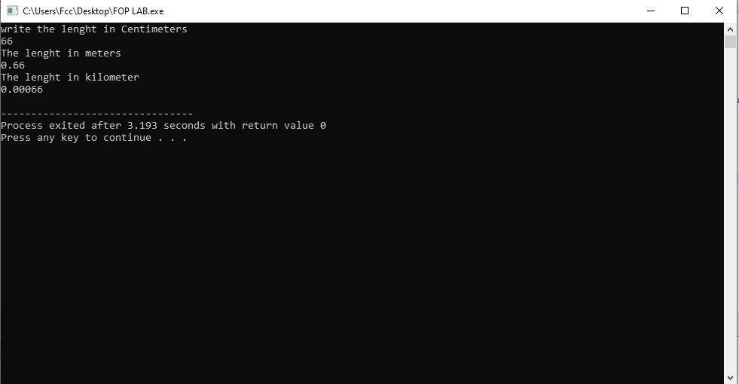

**TASK4: write code that takes value of a and b and displays the result of the polunomial**

#include <iostream>

using namespace std;

//writing the values of variable a and b taken from user and displaying in the polynomial

int main (){

int a,b;

cout<<"write the variable a and b"<<endl; // printing the instruction on the screen so that user knows what data is needed

cin>>a>>b; // creating space for user to write the variables

cout<<"the polynomial is "<<endl;

cout<< a*a + 2*a*b + b*b <<endl; // writing the formula of polynomial for calculations

return 0;

}

